DATA STRUCTURE AND ALGORITHM
Exercise 2: E-commerce Platform Search Function
1.PRODUCT.CS
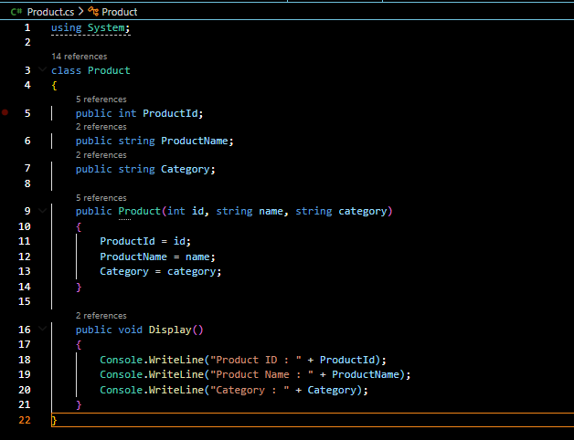
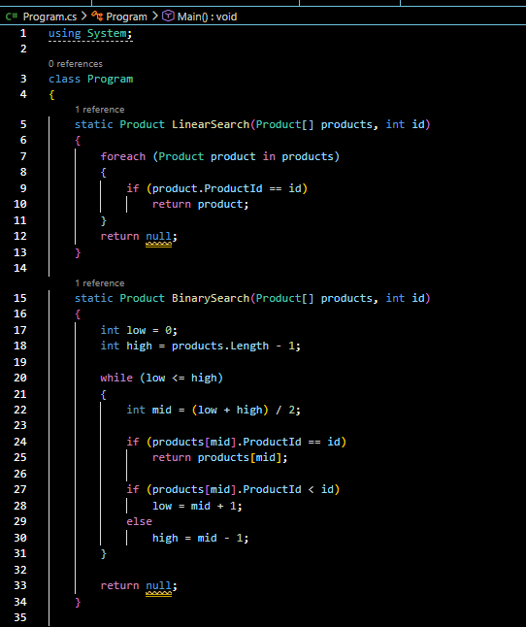
2. PROGRAM.CS

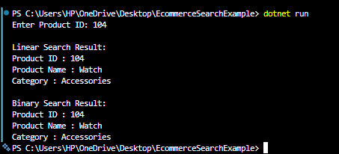
OUTPUT:

Exercise 7: Financial Forecasting
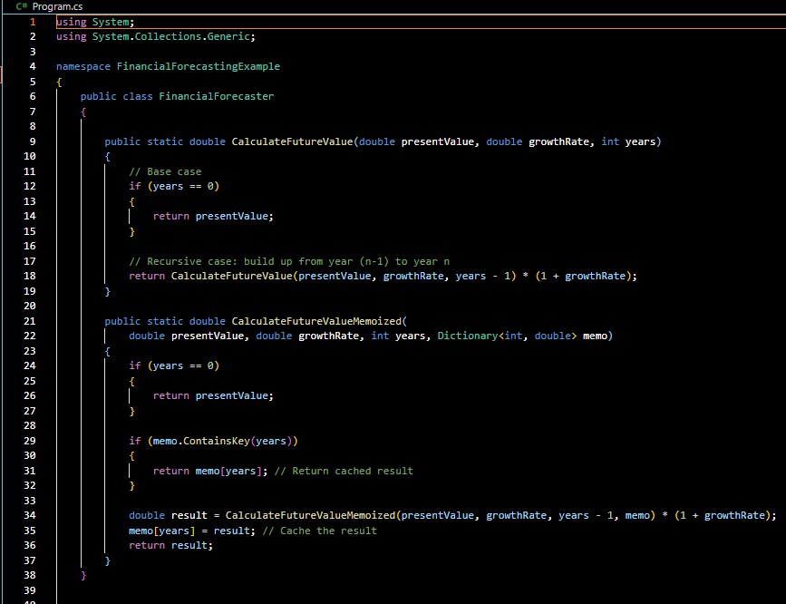
1.PROGRAM.CS

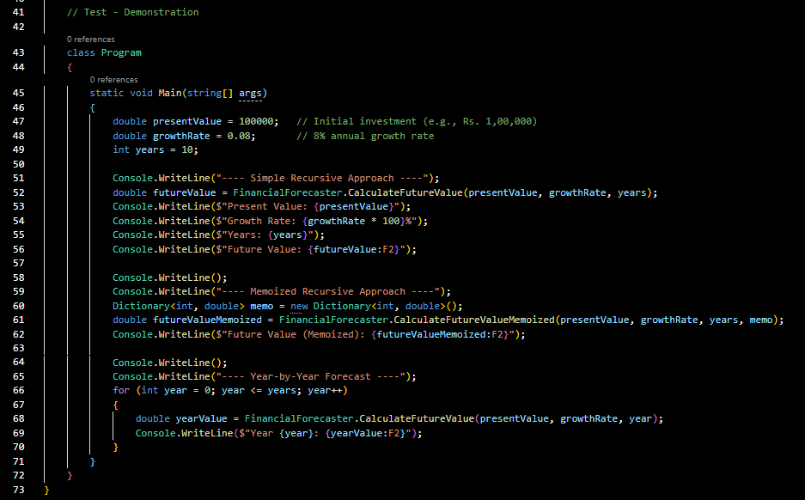

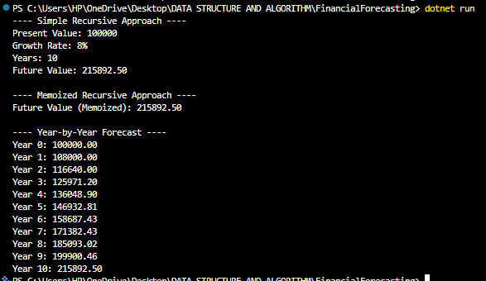
OUTPUT:

